Lab 3 Basic Build Guide
Speedgoat CAN Control for the Dual-Motor PMSM Dyno
what to build, wire, test, and prove

One-sentence goal
Replace the old MATLAB/SCI command and debug path with a Speedgoat-to-C2000 CAN path so Lab 3 can command the same dual-motor dyno system used in Lab 2.

1. What Lab 3 Is
Lab 3 is the communication and integration lab. Lab 2 proved the dual-motor dyno behavior using the existing host model and SCI serial communication. Lab 3 keeps the motor-control idea but changes the communication path: Speedgoat becomes the real-time controller/host, and the LAUNCHXL-F28069M receives commands and sends telemetry over CAN.
Old Lab 2 Path | New Lab 3 Path
MATLAB host sends RPM/Iq/debug over SCI | Speedgoat sends RPM/Iq/mode/debug over CAN
C2000 target receives SCI command packet | C2000 target receives CAN command frames
C2000 sends debug values back over SCI | C2000 sends speed, Iq, torque, and power back over CAN
Data is logged on MATLAB host scopes | Data is logged on Speedgoat scopes/logging

2. Must-Know Sign Convention
Use this sign rule in all Lab 3 analysis
Positive Motor 2 Iq = Motor 2 acts as the load/dyno, so Motor 1 Pm is the meaningful drive-power reading.
Negative Motor 2 Iq = Motor 2 acts as the driver/assist motor, so Motor 2 Pm is the meaningful drive-power reading.

Motor 2 Iq | Motor 2 Role | Main Useful Power Signal
Positive | Load / dyno | Motor 1 Pm
Negative | Driver / assist motor | Motor 2 Pm
Near zero | Transition / little useful loading | Use caution

3. What You Need
Item | Purpose
Speedgoat real-time target | Runs the Lab 3 command, logging, and CAN receive model
LAUNCHXL-F28069M LaunchPad | C2000 motor-control target receiving CAN commands
Two BOOSTXL-DRV8305EVM boards | Motor inverters for Motor 1 and Motor 2
Two PMSM motors mechanically coupled | Dual-motor dynamometer
24 V DC supply | Power for inverter boards
CAN connection between Speedgoat and C2000 | Command and telemetry bus
120 ohm CAN termination | Stable CAN physical layer
Simulink + C2000 support package | Build/deploy C2000 target model
Speedgoat/Simulink Real-Time CAN blocks | Build Speedgoat host model

4. Correct Simulink Block Direction
Important
On the C2000 target model, use the C2000/C28x CAN blocks for the F28069M target. Do not use only the generic desktop CAN blocks inside the C2000 code-generation model. The Speedgoat side should be able to use the Speedgoat/Simulink Real-Time CAN interface blocks.

Model Side | Use This | For This
Speedgoat/Host model | CAN Pack / CAN Transmit / CAN Receive / CAN Unpack or Speedgoat CAN equivalent bblocks | Command generation, CAN TX/RX, logging
C2000 F28069M target model | C28x CAN Receive and C28x CAN Transmit | Receiving commands and transmitting telemetry
C2000 hardware config | CAN_A / eCAN | The CAN peripheral used by the LaunchPad target
Optional development path | SCI left in model as fallback | Debugging if CAN is not working yet

5. Final Architecture
Speedgoat EPA command and load schedule -> CAN command frames -> LAUNCHXL-F28069M target -> PMSM dyno -> CAN telemetry frames -> Speedgoat logging and plots
CAN Direction | Data Moving Across Bus
Speedgoat to C2000 | Enable, mode, trial number, Motor 1 speed reference, Motor 2 Iq reference
C2000 to Speedgoat | Speed feedback, Motor 2 Iq feedback, Motor 1 Pm/Te, Motor 2 Pm/Te, status/faults

6. Simple CAN Message Plan
Start with a small message set. Do not try to send the entire lab in one CAN frame. Use fixed 11-bit CAN IDs and fixed scaling so both models decode the data the same way.
CAN ID | Name | Direction | Contains
0x100 | Command_Status | Speedgoat -> C2000 | Enable, mode, debug/trial number, command counter
0x101 | Speed_Command | Speedgoat -> C2000 | Motor 1 speed reference
0x102 | Iq_Command | Speedgoat -> C2000 | Motor 2 Iq/load reference
0x200 | Target_Status | C2000 -> Speedgoat | Enable state, mode, fault flags, command counter echo
0x201 | Speed_Telemetry | C2000 -> Speedgoat | Speed reference and speed feedback
0x202 | Iq_Telemetry | C2000 -> Speedgoat | Motor 2 Iq reference and feedback
0x203 | Mtr1_Telemetry | C2000 -> Speedgoat | Motor 1 Pm and Te
0x204 | Mtr2_Telemetry | C2000 -> Speedgoat | Motor 2 Pm and Te

Recommended scaling
Speed: int16, 1 RPM/count for first build.
Iq: int16, 0.001 A/count or 0.01 A/count.
Power/Torque: choose a simple fixed scale and document it in both models.
Always include a command counter or heartbeat so you can tell if messages are fresh.

7. Build Checklist
Step | Do This | Done?
1 | Identify the CAN physical pins/connector on the LAUNCHXL-F28069M setup.
2 | Wire CANH, CANL, and required ground/reference between Speedgoat and C2000 side.
3 | Add 120 ohm termination at the two ends of the CAN bus.
4 | Set both sides to the same CAN bit rate, such as 500 kbps or 1 Mbps.
5 | Add C28x CAN Receive blocks to the C2000 target model.
6 | Decode speed/Iq/enable commands and route them to the existing motor-control inputs.
7 | Add C28x CAN Transmit blocks for telemetry.
8 | Build a Speedgoat model that sends command frames and receives telemetry frames.
9 | Run CAN echo test with motors disabled.
10 | Run low-speed command test with small values.
11 | Run positive Motor 2 Iq load test and verify Motor 1 Pm appears.
12 | Run negative Motor 2 Iq assist test and verify Motor 2 Pm appears.
13 | Run the final Lab 3 drive-cycle demonstration.

8. Safety and Timeout Rules
Rule | Reason
Motors stay disabled until CAN echo works. | Prevents accidental motion from bad decoding.
If CAN command timeout occurs, disable PWM or force safe zero command. | Prevents stale command runaway.
Start with low speed and low Iq. | Limits torque and mechanical risk.
Use a command counter/heartbeat. | Confirms commands are updating.
Keep SCI fallback during early testing. | Provides a recovery path if CAN path fails.
Verify sign convention before EPA cycle. | Prevents interpreting load/drive backwards.

9. Bring-Up Sequence
Phase | Test | Pass Condition
Phase 1 | CAN echo test, motors disabled | Speedgoat sends counter; C2000 echoes same counter.
Phase 2 | Decode test, motors disabled | C2000 decodes enable, speed, and Iq correctly.
Phase 3 | Low-speed Motor 1 test | Motor 1 follows a small speed command.
Phase 4 | Positive Iq load test | Motor 2 loads shaft; Motor 1 Pm becomes meaningful.
Phase 5 | Negative Iq assist test | Motor 2 drives/assists; Motor 2 Pm becomes meaningful.
Phase 6 | Lab 3 full run | Speedgoat commands drive cycle and logs all required telemetry.

10. What Students Need to Submit
Deliverable | What It Should Show
CAN architecture screenshot | Speedgoat command path and C2000 CAN receive/transmit path
CAN message table | IDs, directions, signals, scaling, and update rates
Echo test result | Speedgoat-C2000-Speedgoat communication works
Speed tracking plot | Motor 1 speed reference vs speed feedback
Motor 2 Iq plot | Iq reference and feedback
Power/torque plots | Motor 1 and Motor 2 Pm/Te
Sign-convention explanation | Positive Iq = Motor 2 load; negative Iq = Motor 2 driver
Short conclusion | Whether Lab 3 successfully replaced SCI with CAN

11. Minimum Successful Lab 3
Minimum pass condition
A student should be able to say: Speedgoat sent speed and Iq commands over CAN, the LAUNCHXL-F28069M target received and applied them, the dual-motor dyno responded, and C2000 telemetry returned over CAN to Speedgoat for logging.

12. Five-Line Summary
- Lab 3 replaces SCI with CAN.
- Speedgoat becomes the real-time host/controller.
- The C2000 F28069M target uses C28x CAN Receive/Transmit on CAN_A.
- Start with echo test, then command test, then low-speed motor test, then full dyno test.
- Use the corrected sign convention: positive Motor 2 Iq loads Motor 1; negative Motor 2 Iq means Motor 2 is driving.

Appendix. Reference Screenshots From Current Model
Figure A-1. Current host-side SCI transmit/receive pathway that Lab 3 replaces with CAN command and telemetry paths.
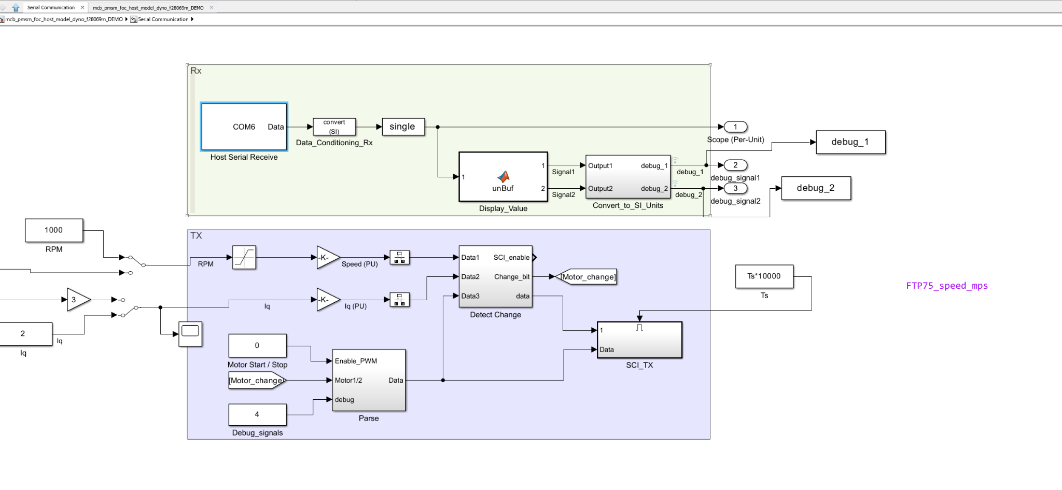

Figure A-2. Current C2000 target SCI transmit block area, indicating where CAN telemetry transmission should be added for Lab 3.
